**Experiment No.: 05**

**Aim:** Write a program to implement logical AND using the Adaline network

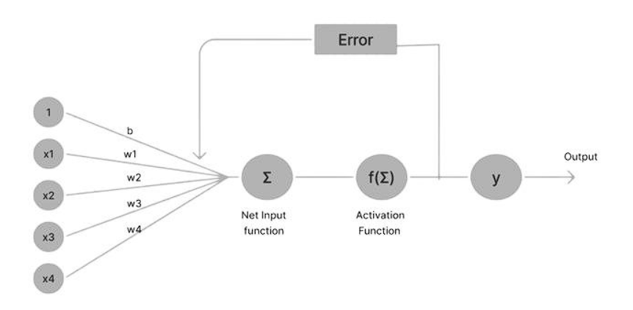

**Steps**:

1. **Initialize Parameters:**
   * Set initial weights **w1** and **w2** to 0.1. Set the learning rate (**learning_rate**) to 0.1.Set the initial bias (**bias**) to 0.1.
2. **Define Input Patterns:**
   * Define input patterns **xi** as [(1, 1), (1, 0), (0, 1), (0, 0)].
3. **Iterative Training:**
   * For each input pattern **x** in **xi**:
     + Calculate the linear combination: **linear_combination = w1 * x[0] + w2 * x[1] + bias**.
     + Calculate the target output: **target_output = x[0] * x[1]**.
     + Calculate the difference between target and actual output:

**diff_output = target_output - linear_combination**.

* + - Calculate the error: **error = pow(diff_output, 2)**. and Update total error: **terr = error + terr**.
    - Update weights and bias using the perceptron learning rule:
      * **w1 = w1 + learning_rate * diff_output * x[0]**
      * **w2 = w2 + learning_rate * diff_output * x[1]**
      * **bias = bias + learning_rate * diff_output**

1. **Output and Convergence Check:**
   * Print total error after processing: **print("Total Error after processing all examples:", terr)**.
   * Create a DataFrame (**output_frame**) to display input, linear combination, activation output, weights, bias, and error for each example.Print the DataFrame.
2. **Convergence Check and Recursion:**
   * Check if the total error (**terr**) is less than the specified maximum error (**MaxErr**).
   * If not converged, print "Convergence achieved. Error:" and call the **cal_output_and** function recursively with updated weights and bias.

**Code:**

import numpy as np

import pandas as pd

def cal_output_and(w1, w2, learning_rate, bias, MaxErr=1):

xi = [(1, 1), (1, 0), (0, 1), (0, 0)]

outputs = []

terr=0

for x in xi:

linear_combination = w1 * x[0] + w2 * x[1] + bias

target_output = x[0] * x[1]

diff_output = target_output - linear_combination

error = pow(diff_output, 2)

terr=error+terr

w1 = w1 + learning_rate * diff_output * x[0]

w2 = w2 + learning_rate * diff_output * x[1]

bias = bias + learning_rate * diff_output

outputs.append([x[0], x[1], linear_combination, target_output,w1,w2,bias,error])

print("Total Error after processing all examples:", terr ) # Corrected total error calculation

output_frame = pd.DataFrame(outputs, columns=['Input 1', 'Input 2', 'Actual Output', 'Target Output', 'w1', 'w2', 'bias', 'Error'])

print(output_frame.to_string(index=False))

if MaxErr < terr:

print("Convergence achieved. Error:", terr)

print("\nNext Epoch")

cal_output_and(w1, w2, learning_rate, bias)

return

w1 = 1

w2 = 1

learning_rate = 0.2

bias = 0.5

cal_output_and(w1, w2, learning_rate, bias)

**Output:**

